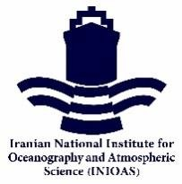
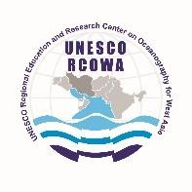
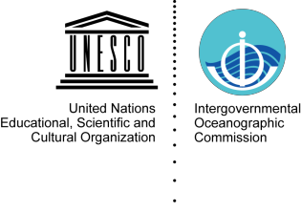

RCOWA 5/2

FIFTH SESSION OF THE GOVERNING BOARD OF UNESCO CATEGORY 2 REGIONAL
EDUCATION AND RESEARCH CENTRE ON OCEANOGRAPHY FOR WEST ASIA (RCOWA)
(12:00 – 14:00 Tehran Time, 14th February 2022, Online)

PROVISIONAL AGENDA

- OPENING AND WELCOME
- ORGANIZATION OF THE SESSION
- RCOWA ACTIVITIES REPORT IN 2021
- REPORT ON EVALUATION OF RCOWA ACTIVITIES AND STATUS OF EXTENSION OF AGREEMENT OF RCOWA ESTABLISHMENT
- WORKPLAN FOR 2022
- OTHER MATTERS
- DATES and PLACE OF THE SIXTH SESSION OF THE RCOWA GOVERNING BOARD
- ADOPTION OF SUMMARY REPORT AND RECOMMENDATIONS
- CLOSURE

