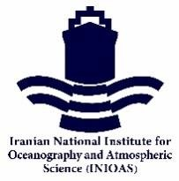
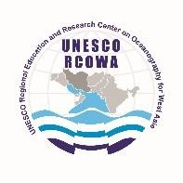
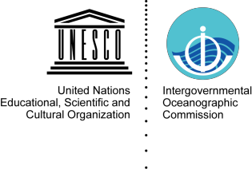

RCOWA 5/1

FIFTH SESSION OF THE GOVERNING BOARD OF UNESCO CATEGORY 2 REGIONAL
EDUCATION AND RESEARCH CENTRE ON OCEANOGRAPHY FOR WEST ASIA (RCOWA)
(12:00 – 14:00 Tehran Time, 14th February 2022, Online)

LIST OF DOCUMENTS

WORKING DOCUMENTS
- LIST OF DOCUMENTS (RCOWA 5/1 – this document)
- PROVISIONAL AGENDA (RCOWA 5/2)
- ANNOTATED PROVISIONAL AGENDA (RCOWA 5/3)
- LIST OF PARTICIPANTS (RCOWA 5/4)
- REPORT OF THE RCOWA ACTIVITIES 2021 (RCOWA 5/5)
- WORK PLAN AND BUDGET FOR 2022 (RCOWA 5/6)
INFORMATION DOCUMENT
- Report of the 4th Session of the RCOWA C-2-C Governing Board
- Agreement between UNESCO and Iranian Ministry of Science, Research, and Technology (MSRT) on the establishment of RCOWA
- Letter of IOC for endorsement of RCOWA Decade Action entitled “The West Asia Blue Waters, ID 131” as a project forming part of the UN Decade of Ocean Science for Sustainable Development 2021-2030.

